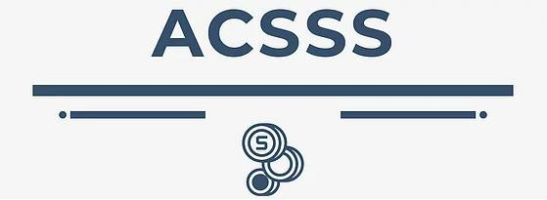

ACSSS Board Meeting

October 10, 2023

Microsoft Teams meeting

CONFIDENTIAL - FOR ACSSS BOARD MEMBERS ONLY

|  |  |  |
| --- | --- | --- |
|  | **Agenda Topic** | **Presenter** |
| 1. | Call to Order | Kevin Allard |
| 2. | Attendance (verified via Teams) & Welcome New Member | Mary Beth Quist |
| 3. | 2Q Financial Report ([supporting documents](https://csbs-my.sharepoint.com/personal/zgluck_csbs_org/Documents/ACSSS/ACSSS%20Financials_09.30.23.pdf)) | Monica Lockett |
| 4. | Community Banker Sentiment Index and Economic Update  Q2 2023 CBSI: <https://www.csbs.org/cbindex> Key Highlights:  * **95% of community bankers believe the U.S. economy is currently in a recession.** * Community banker sentiment has been pessimistic for six straight quarters. * All seven components that comprise the CBSI decreased from the previous quarterly survey. * Community bankers rated the following as their top concerns for 2023: **government regulation, cyberattacks, inflation, federal debt/deficit and the cost/availability of labor.** |  |
| 5. | Financial & Banking Information Infrastructure Committee (FBIIC) Report | Mary Beth Quist  Kevin Allard  Jonathan Finley |
| 6. | Federal Financial Institutions Examination Council (FFIEC) Report   * September SLC Briefing and Council Meeting * Current Projects of Note | Mary Beth Quist  Kevin Allard |
| 7. | Adjournment | Kevin Allard |
| Member Terms ([Document for your review](https://csbs-my.sharepoint.com/personal/zgluck_csbs_org/Documents/ACSSS/ACSSS%20Board%20Members%20and%20Terms%20September%202023.docx)) | | |